Online Course Design Roadmap Part 1

Exploring Taxonomies and Learning Outcomes

DIRECTIONS:
Draft at least three learning outcomes for a unit of learning in your online course. Aim to incorporate various levels/quadrants from both Bloom’s and Fink’s taxonomy as applicable to your design context. Example verbs are provided in the links beneath the example taxonomy images.

USING BLOOM’S
EXAMPLE LEARNING OUTCOMES
1. Creating  [INSERT LEARNNG OUTCOME HERE, etc.] | 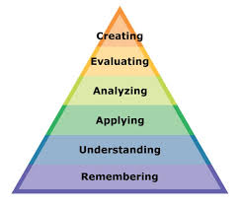  View list of helpful verbs per Bloom’s taxonomy
2. Evaluating

3. Analyzing

4. Applying

5. Understanding

6. Remembering

USING FINK’S
EXAMPLE LEARNING OUTCOMES
1. Foundation Knowledge  [INSERT LEARNNG OUTCOME HERE, etc.] | 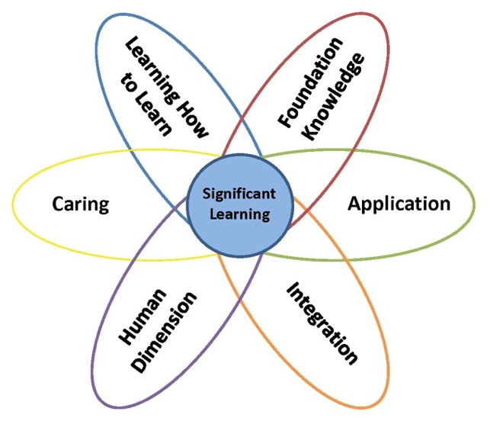  View list of helpful verbs per Fink’s taxonomy
2. Application

3. Integration

4. Human Dimension

5. Caring

6. Learning how to Learn

Retrieved and adapted from:
Armstrong, P. (2010). Bloom’s Taxonomy. Vanderbilt University Center for Teaching. Retrieved [September, 08, 2022] from https://cft.vanderbilt.edu/guides-sub-pages/blooms-taxonomy
Fink, L. D. (2016). Design Tips and Forms. Designing Significant Learning Experiences.

