I have an idea...
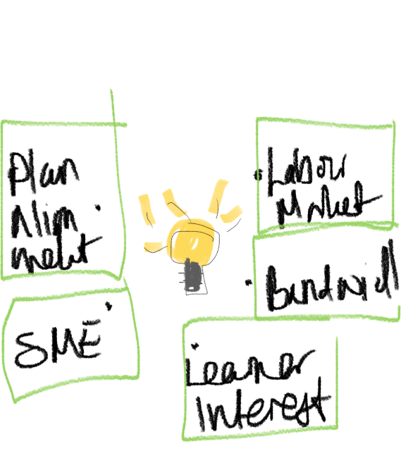

All microcredentials start with an idea. Before a project to develop a new course or program can begin, an initial analysis needs to be undertaken to determine whether conditions are right for moving forward. In any new initiative, the first step is to have a clear sense of what you are trying to achieve.

Early steps in consultation and research may include the following strategies:
- Conduct gap analysis or environmental scan to determine current training needs.
- Connect with local experts or partners within the profession or skill area to inquire if they are interested in participating in a working group or focus group.
- Consider forming a working group that meets on an ongoing basis to determine the training needs, including upskilling or new skills that are in demand.
- Engage key stakeholders to clarify the purpose of a micro-credential, or what need the micro-credential will address.
Below are some key considerations and critical early questions to discuss.

1.0 Rationale
Is the strategic intent understood?
It is imperative to know why you want to develop microcredentials, which necessitates identifying the goals of your initiative. Are these, for example, to respond to student demand for more relevant future skills, to make learning personalized, to break it into smaller, bite-sized chunks, or perhaps to work more closely with industry to ensure graduates gain mastery of work-ready skills? The options are wide but not mutually exclusive. Understanding the strategic intent will help you describe the benefits to your stakeholders, particularly to key players such as the credential earners and the reviewers or consumers of the credentials (e.g., employers and other educational institutions).

1.1 Labour Market Demand
Is there labour market demand?
All Ontario funded (OSAP eligible, Challenge Fund) microcredentials are meant to be responsive to labour market demand. Your institution may already have infrastructure for offering continuing, professional and executive education and may have internal processes for conducting this analysis. There are also external providers that will conduct this analysis for a fee. Visit the labour market page [link to Labour Market page] for assessing labour market demand and designing offerings in response to assessed demand.

1.2 Assessing Capacity and Alignment
Is this idea aligned with the priorities and plans of my unit, division and the university?
The experience of most institutions that are new entrants into the microcredential design and delivery is that all stages take more time and effort than originally expected. To deliver a high-quality offering requires the participation of many individuals. In the case of appointed faculty and staff, the initial assessment needs to include consideration of what these individuals will not do in order to make time to work on the microcredential project. How will core academic courses, programs, or student supports be sustained if individuals are focused on the microcredential project? Note that teaching in continuing, professional and executive education programming is normally considered to be outside of assigned workload for appointed faculty and appropriate costs of any backfilling or overload will have to be considered.
Feasibility:
- Has consideration been given to how the microcredential will align with institutional and divisional priorities (e.g., academic plan, strategic mandate agreements), institutional microcredential policies, and unit plan resourcing prioritization?
- Can you identify a team of possible collaborators within your unit or within the university?
- Have you reviewed necessary curricular and quality assurance processes and identified approval pathways for required approvals?
- Has an initial budget been created? It may be possible to identify and apply for internal or external funding opportunities to support the design of the microcredential. Consider learner and employer pricing sensitivity, and marketing plan and costs.
- Is the infrastructure and business process capacity in place to support a high-quality offering for learners? Consider partnering with established divisional partners, or third-party organizations.

1.3 Assessing Learner Demand
Is there learner demand for the offering?
Having conversations with industry experts can be informative in assessing learner demand. The more industry experts are involved, the more likely the content will be developed to meet their current needs.

1.4 External Partnerships:

Is there an external industry or community partner who is invested in this idea?

Continuing education activities offered by your institution may from time to time involve collaboration with external organizations, such as other post-secondary institutions, affiliated and unaffiliated hospitals and health-care institutions, industry, regulatory bodies, governments and governmental agencies, etc.
You may customize activities to ensure that the design and content match the needs of the external organization, provided that the activity remains in accordance with university and divisional policies and practices.
Check and confirm if customized activities require decanal approval.
1.5 Contracts (including third-party providers):
If a contract with a third-party organization is being considered, is it in compliance with University policy?
Many of the details associated with continuing, professional and executive education activities, including microcredentials, are ultimately captured in one or more contracts or agreements (for example, instructor contracts, service contracts, facilities agreements, etc.).
Please contact your institution’s relevant office (e.g., Dean) to ensure contracts and agreements are developed in compliance with university policies and guidelines.

